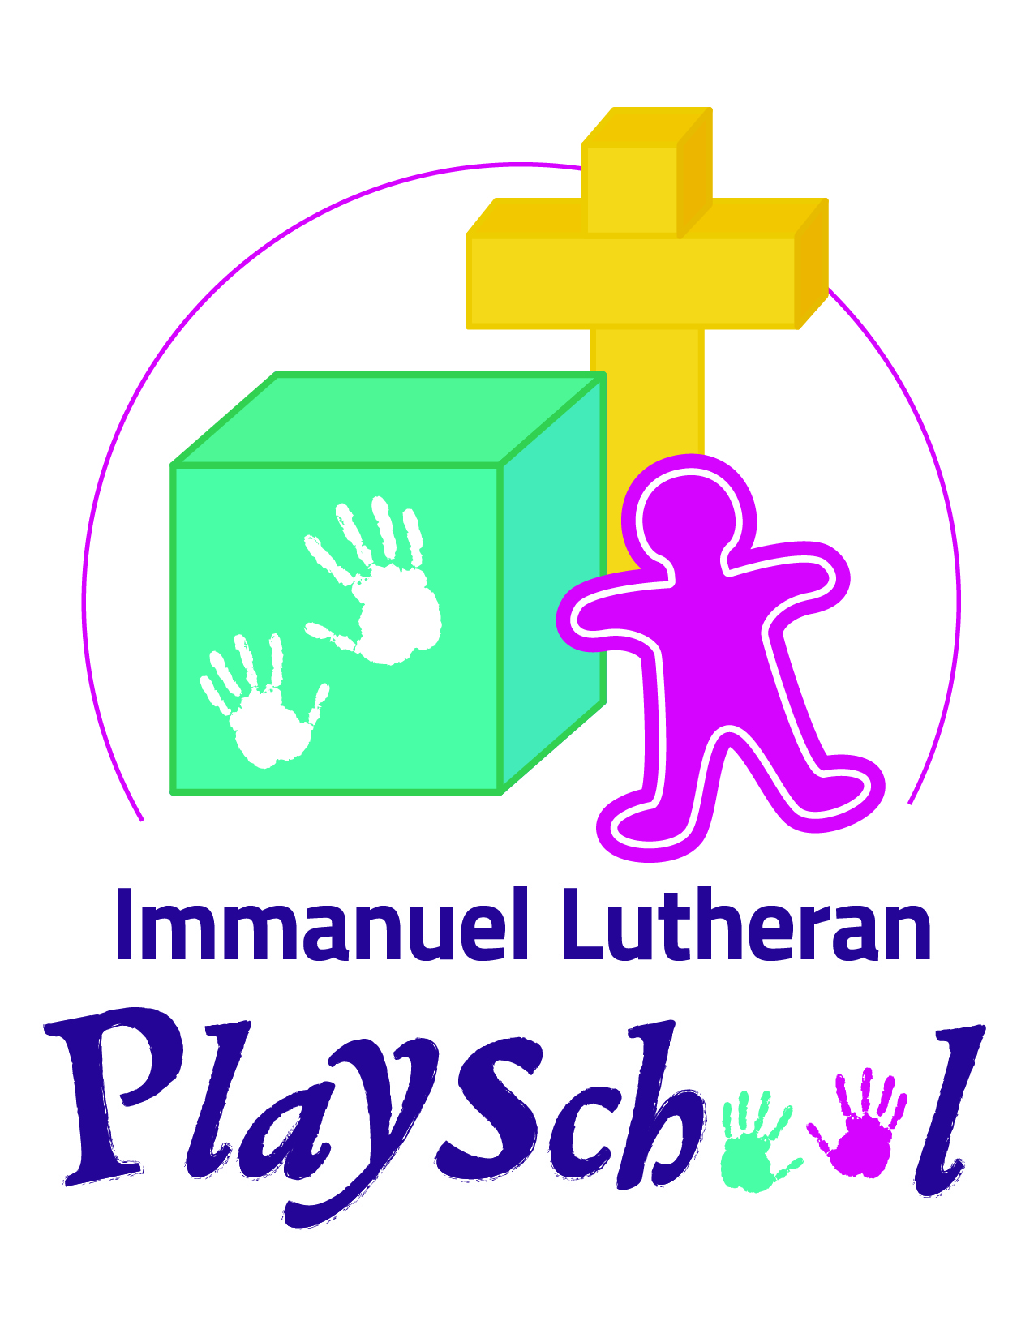

5236 – 54st Street Rocky Mountain House AB,
(403) 845-2063
www.immanuellutheranplayschool.weebly.com
Email: immanuellutheranplayschool@gmail.com

CHILD’S INFORMATION:
Child’s Full Name: ___________________________________________________________________________________
Date of Birth: _______________________________________________________________________________________
Child’s home address: _________________________________________________________Postal Code_____________
Child’s home phone number: __________________________________________________________________________
Gender of Child (please circle): Male Female
Allergies? If so please list: _____________________________________________________________________________
Any Medical problems of which we should be aware of: ____________________________________________________
__________________________________________________________________________________________________

Playschool staff may administer First Aid in case of an emergency: Yes / No ____________________________________
Parent/Guardian Signature
PARENT/GUARDIAN INFORMATION
Family email address: ________________________________________________________________________________
Father’s Name: _____________________________________________________________________________________
Father’s Phone Number: ______________________________ Cell: ___________________Work: ___________________
Mother’s Name: ____________________________________________________________________________________
Mother’s Phone Number: ____________________________ Cell: ____________________Work: ___________________
FAMILY INFORMATION
Brother’s and/or sisters: Name Age ln home with child: Y/N
____________________________________________________________________________________________________________________________________________________________________________________________________
__________________________________________________________________________________________________
Please list any other persons living with the child and their relationship (if any) to the child:
__________________________________________________________________________________________________
__________________________________________________________________________________________________

TIMES AND DAYS OF WEEK
I wish my child to be enrolled: Tues. a.m. Tues. p.m. Thurs. a.m. Thurs. p.m.

PICK UP OF CHILD
Persons who are UNAUTHORIZED to pick up the child:

__________________________________________________________________________________________________

AUTHORIZED EMERGENCY CONTACTS:
Name: ______________________________________ Name: ________________________________________

Phone: __________________ Cell: _________________ Phone: __________________ Cell: _________________

PERSONAL HISTORY
Has your child had a previous group interaction or preschool experience? ___________ If so, where and when: _______
__________________________________________________________________________________________________
What words does your child use for toileting? ____________________________________________________________
Does your child have any bowel or bladder irregularities? ___________________________________________________
__________________________________________________________________________________________________
What is your child’s concept of God? ____________________________________________________________________
__________________________________________________________________________________________________
Add additional information related to discipline related to discipline, child’s communication, comforting habits:
__________________________________________________________________________________________________
__________________________________________________________________________________________________

HOW DID YOU HEAR ABOUT IMMANUEL LUTHERAN PLAYSCHOOL?
Rocky Rec guide Website Friend Other_____________

There is a $20.00 non-refundable registration fee to hold your child’s spot. Please hand in with registration form

Student Discipline & Potential Health Risk Policy

DISCIPLINE POLICY:
At Immanuel Lutheran playschool each child is regarded as a special gift from God and is treated with Christian love and respect. We encourage using “words” to express our feelings and when adult intervention is required to assist in a situation that has arisen, the least restrictive alternative will be the first approach that is used. Any disciplinary action taken will be reasonable in the circumstances.
If an incident occurs between children, we will find a quiet place, talk over the problem, resolve their differences, and then encourage the children to say, “I’m sorry” and “It’s OK, I forgive you.” We will always suggest first that words be used to express the feelings that the child/children is/are experiencing. If the child/children can express his/her feelings on their own, then the adult will reinforce this expression and may assist the children to work out their difficulty, encouraging problem solving on the part of the children. If the child requires assistance to express their feelings, the adult can offer words to the child (e.g. “Sarah, you look like you’re feeling frustrated or angry right now.”). If encouraging problem solving between the children is not effective, redirection or substitution can then be exercised (e.g. “Sarah, how about if you try building with these blocks instead? Would you like to use red or blue?”).
We believe in natural consequences for behavior, for example, “Tommy, if you are going to hit Sarah’s head with the paintbrush, you may not use the paintbrush.” Positive behavior will receive maximum attention, while negative behavior will receive the minimum intervention required. When a negative behavior persists, parents will be called to hear our concern and to share their insight.
An adult in this program will not use any form of physical punishment, such as hitting or slapping. Children will not be subjected to the use of any form of physical degradation or emotional deprivation such as humiliation or isolation.
When a problem arises, the parent helper should make sure the teacher is aware of the problem.
ONLY the teacher will discipline children.
Together we can develop a strategy to help the child act in a more responsible way.

Signature: ____________________________________________________ Date: _____________________

Potential Health Risk Policy
An Ill child will be defined as a child who:
Is vomiting, has a fever, diarrhea or a new unexplained rash or cough;
Requires greater attention than can be provided without compromising the care of other children in the program;
Displays any other illness or symptom the staff member knows or believes may indicate that a child poses a health risk to the other children, caregivers or staff.
Staff will assess if a child is ill when a staff knows or has reason to believe a child is exhibiting the signs or symptoms of illness as described above.
When a staff member knows or has reason to believe a child is exhibiting the signs or symptoms of illness, the license holder will ensure that the child’s parent arranges for the immediate removal of the ill child from the program’s premises. The child’s parent will be contacted by telephone to make arrangements for the child’s removal. If the child’s parent is not available, the emergency contact persons will be contacted to make arrangements to remove the child from the program’s premises.
A child can return to the program if the child’s parent provides a written notice from a physician indicating that the child does not pose a health risk or if the child is symptom free for at least 24 hours. The child may return to the program if the staff is satisfied that a child no longer poses a health risk to other children, caregivers or staff.
Immanuel Lutheran Playschool will record and document children who are ill. The documenting will include the name of the child, date the child was observed to be ill, name of staff member who identified the child was ill, time the parent was initially contacted, name of staff person who contacted the parent, time the child was removed from the program and the date the child returned to the program.
If a parent fails to arrange for the immediate removal of a child, the program will contact the child’s emergency contact persons as listed on the child’s registration form, to make arrangements for the child’s immediate removal from the program.
If the ill child’s removal is delayed the ill child will be kept as far away from other children as possible and the child will be directly supervised by a staff member until the child is removed.

Signature: ____________________________________________________ Date: _____________________
Freedom of Information and Protection of Privacy (FOIP) Consent Form
Notice of Activities
Under the Freedom of Information and Protection of Privacy (FOIP) Act, the use of personal information of our students in activities conducted by the playschool requires the consent of parents/guardians. Below is a list of activities that we consider a part of normal school community interaction:

- Taking of individual and class photos for the classroom
- Students names, photographs and write ups that are included in the memory books (if one produced)
- Student names that are used for birthday recognition purposes
- Media photographs or videos of classroom activities, where individuals cannot be identified
- Student names that are used on artwork, written material or other items to be displayed in the classroom, within the church or school sponsored displays in the community
- Providing personal information to health authorities for the provision of public health services and communicable disease control
- Phone lists of all students for school related use (parent volunteer schedules, class cancellations etc.)

I have read the Notice of Activities and herby consent to the collection, use and disclosure of the information listed there on behalf of my child/ward.

Student’s Name (Please Print):______________________________________Date:_______________________

Parent/Guardian Name (Please Print):_________________________________Date:______________________

Parent/Guardian Signature: ___________________________________________________________________

Further to the “normal” activities listed above, there may be instances where the playschool and our students are featured in local media i.e. newspaper articles or advertisements for the playschool. This may involve either photographs or videos taken by the teacher or by the media or any other organization where individual students are identified or instances where students are interviewed where the material will be used outside of the school.

Please sign below if you give consent for the collection, use and disclosure of the information for purposes outlined in the paragraph above on behalf of your child/ward.

Parent/Guardian Signature: __________________________________________________________________

Portable Emergency Information Record
(All Blanks must be filled in)
Child’s Name: _______________________________________________________________________
Date of Birth: ________________________________________________________________________
Child’s Address: ______________________________________________________________________
Child’s Home Phone Number: ___________________________________________________________

Father’s Name: ______________________________________________________________________
Work Phone: _________________ Cell (if applicable): _________________ Home: ________________

Mother’s Name: ______________________________________________________________________
Work Phone: _________________ Cell (if applicable): _________________ Home: ________________

AUTHORIZED EMERGENCY CONTACTS:
- Name: ___________________________________________________________________________

Phone: _________________________________________ Cell: _____________________________

- Name: ___________________________________________________________________________

Phone: _________________________________________ Cell: _____________________________

Health Information:

Allergies: ____________________________________________________________________________

Medications: _________________________________________________________________________

Instructions: _________________________________________________________________________
_________________________________________________________________________
_________________________________________________________________________

